**AWS Task 4**

Step1: Launched a Linux EC2 instance, connected to the instance, Installed Apache Web Server

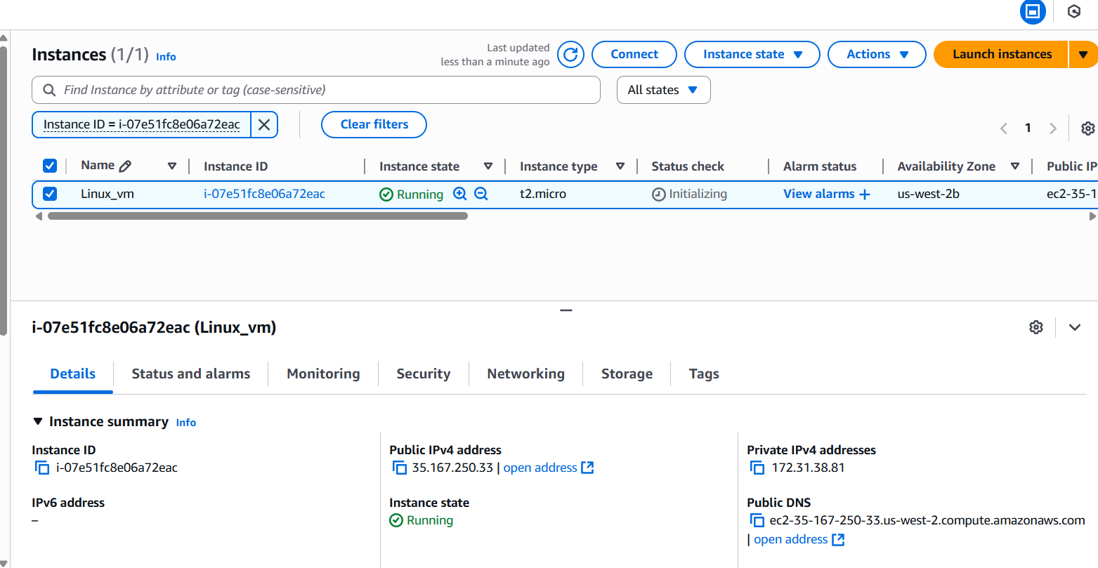

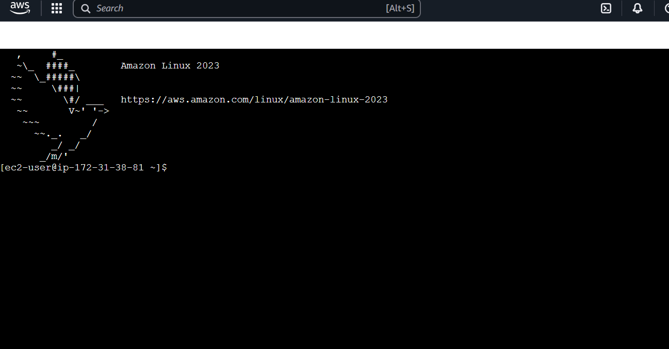

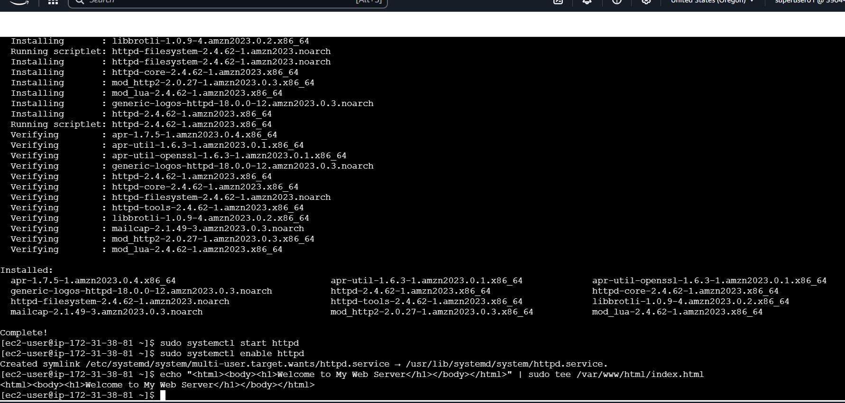

Step2: Opened the web browser by navigating to the public IP of the Linux EC2 instance.

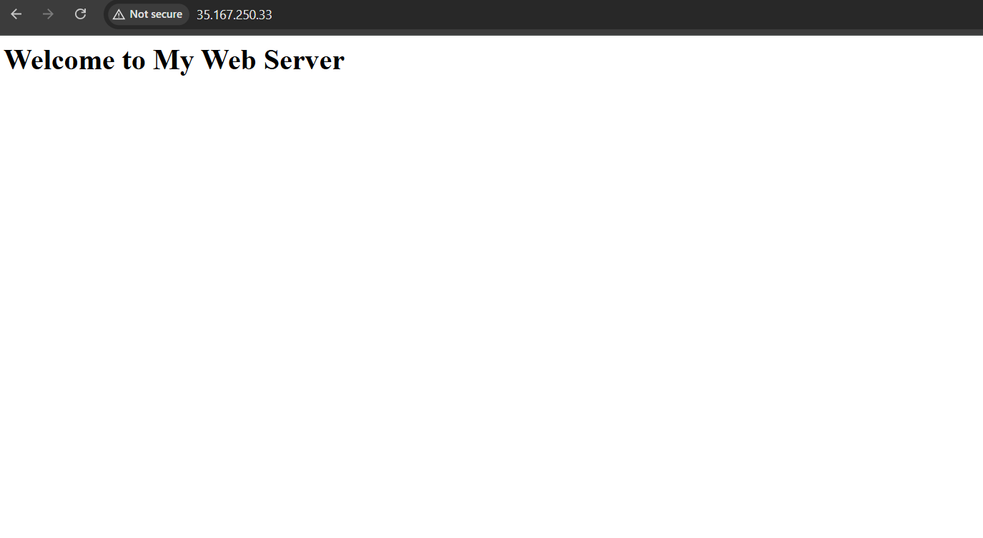

Step3: Created and attached a 5GB EBS Volume to the Linux instance, mounted the volume in ssh, created the snapshot for the 5GB EBS Volume

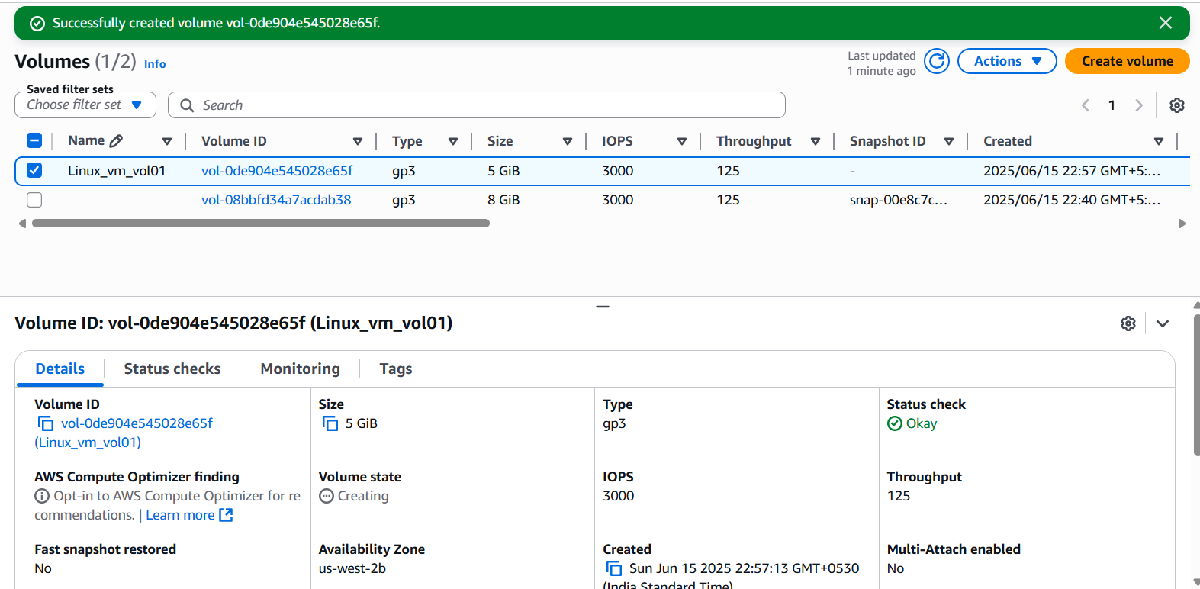

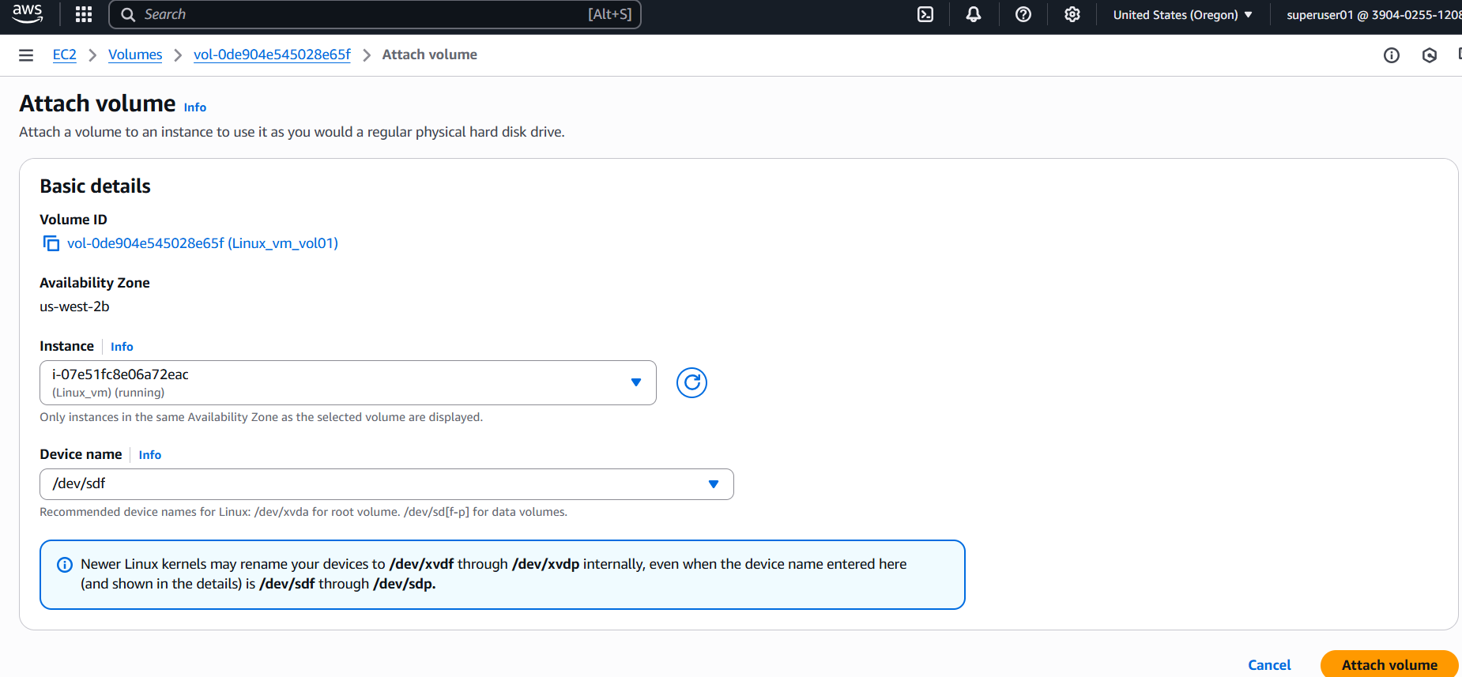

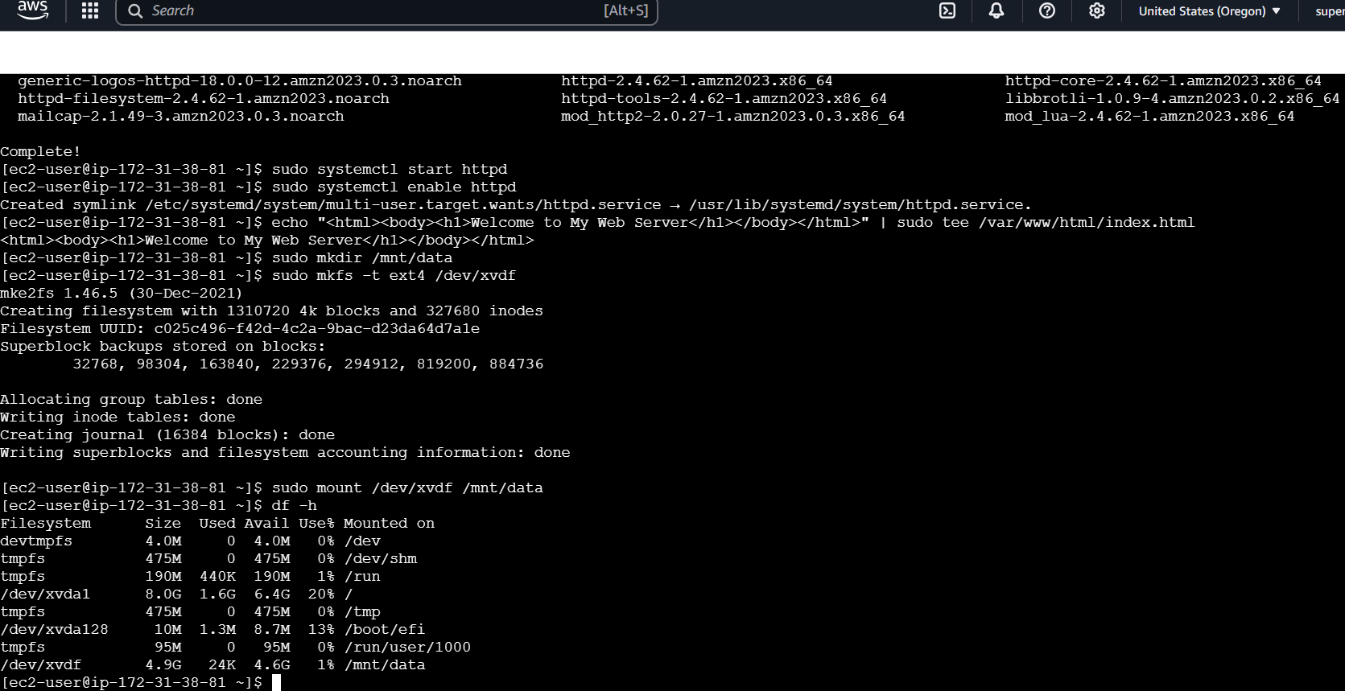

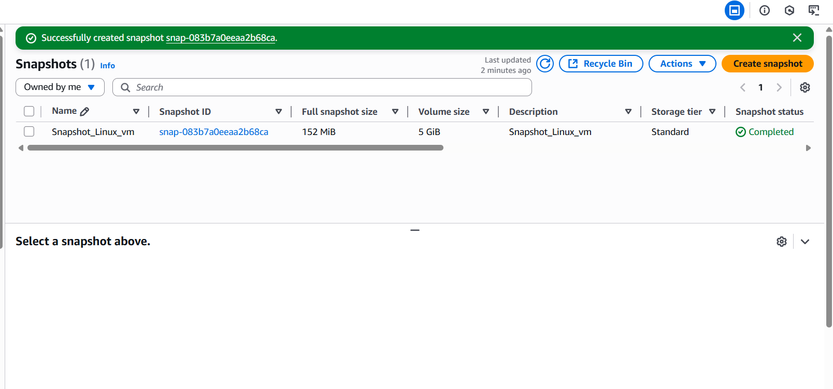

Step5: Created a new EBS volume from the snapshot

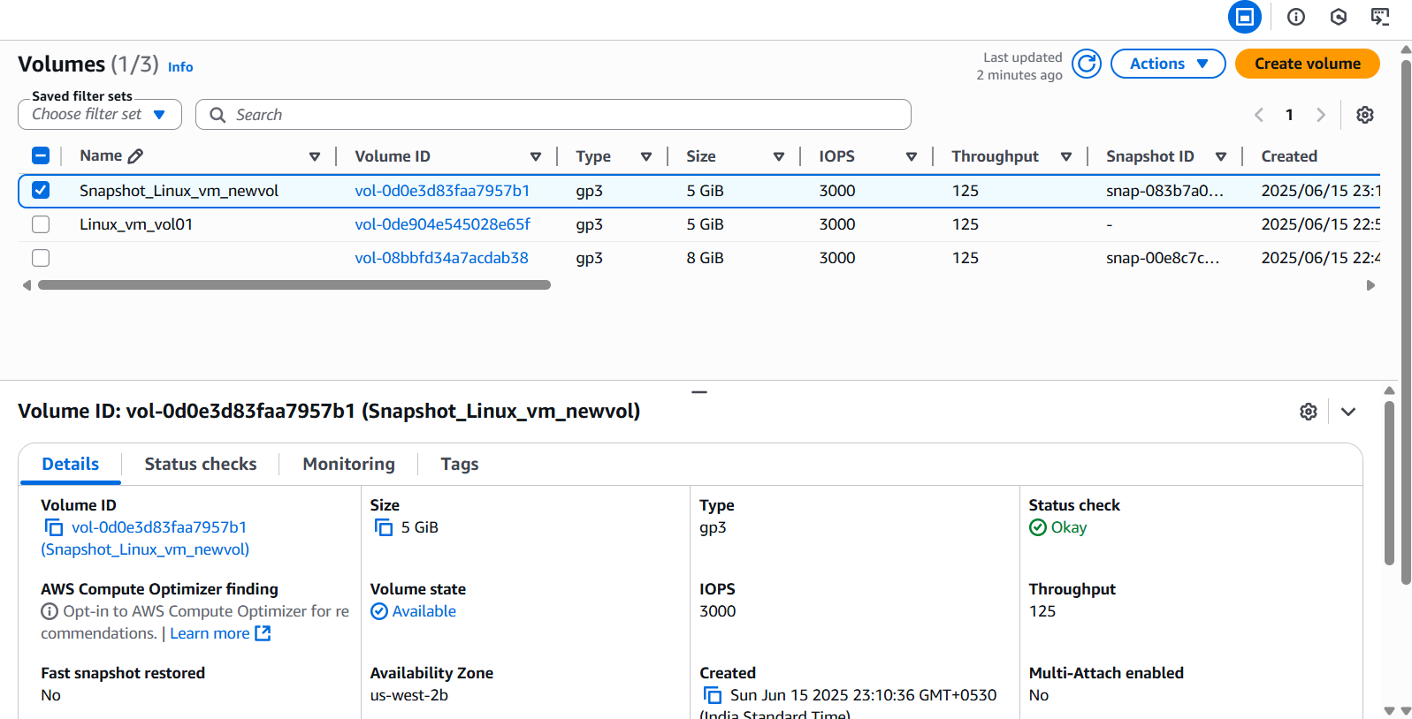

Step 1: Launched a Windows EC2 Instance

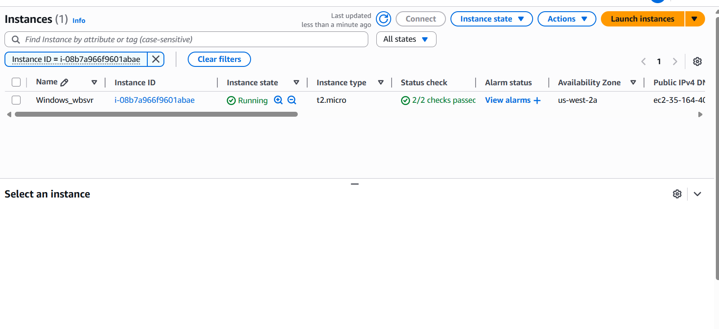

Step 2: Installed Web Server on Windows

Connected the instance via RDP

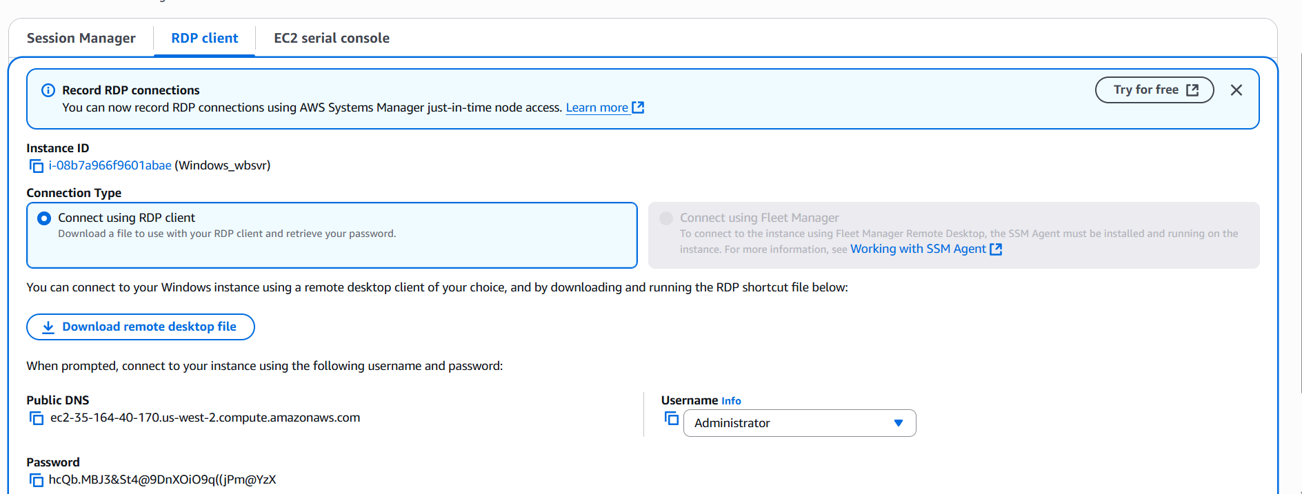

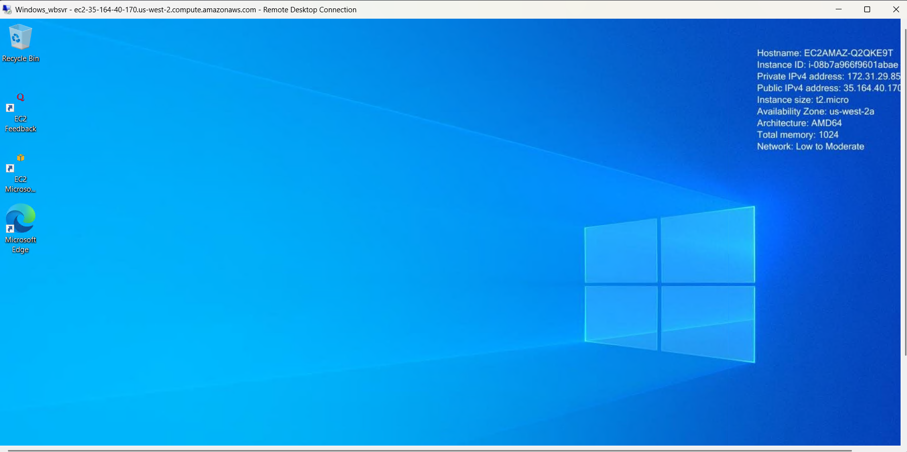

Launched server manager and Added roles and features to the server manager

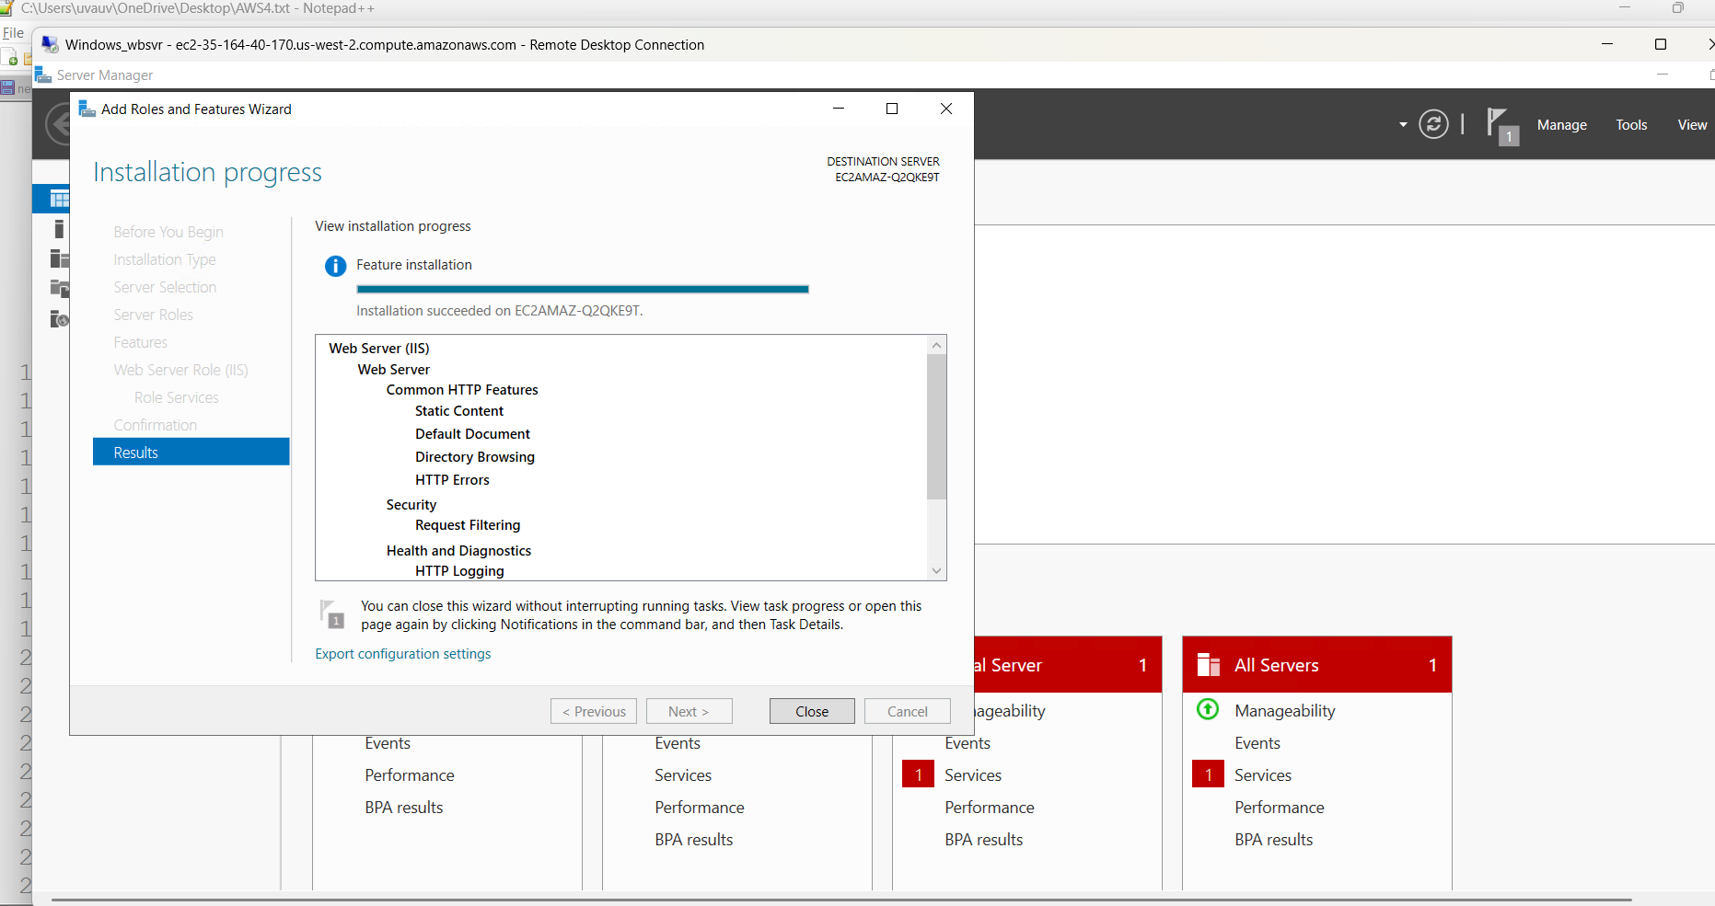

Verified IIS is running

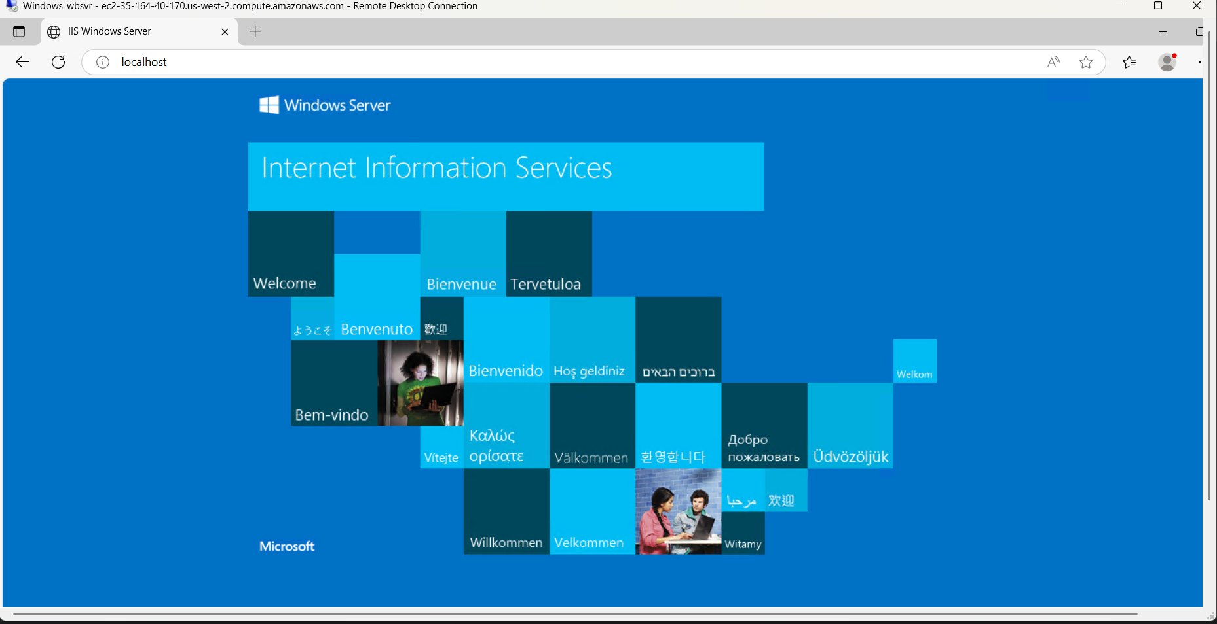

Check from outside(Public access)

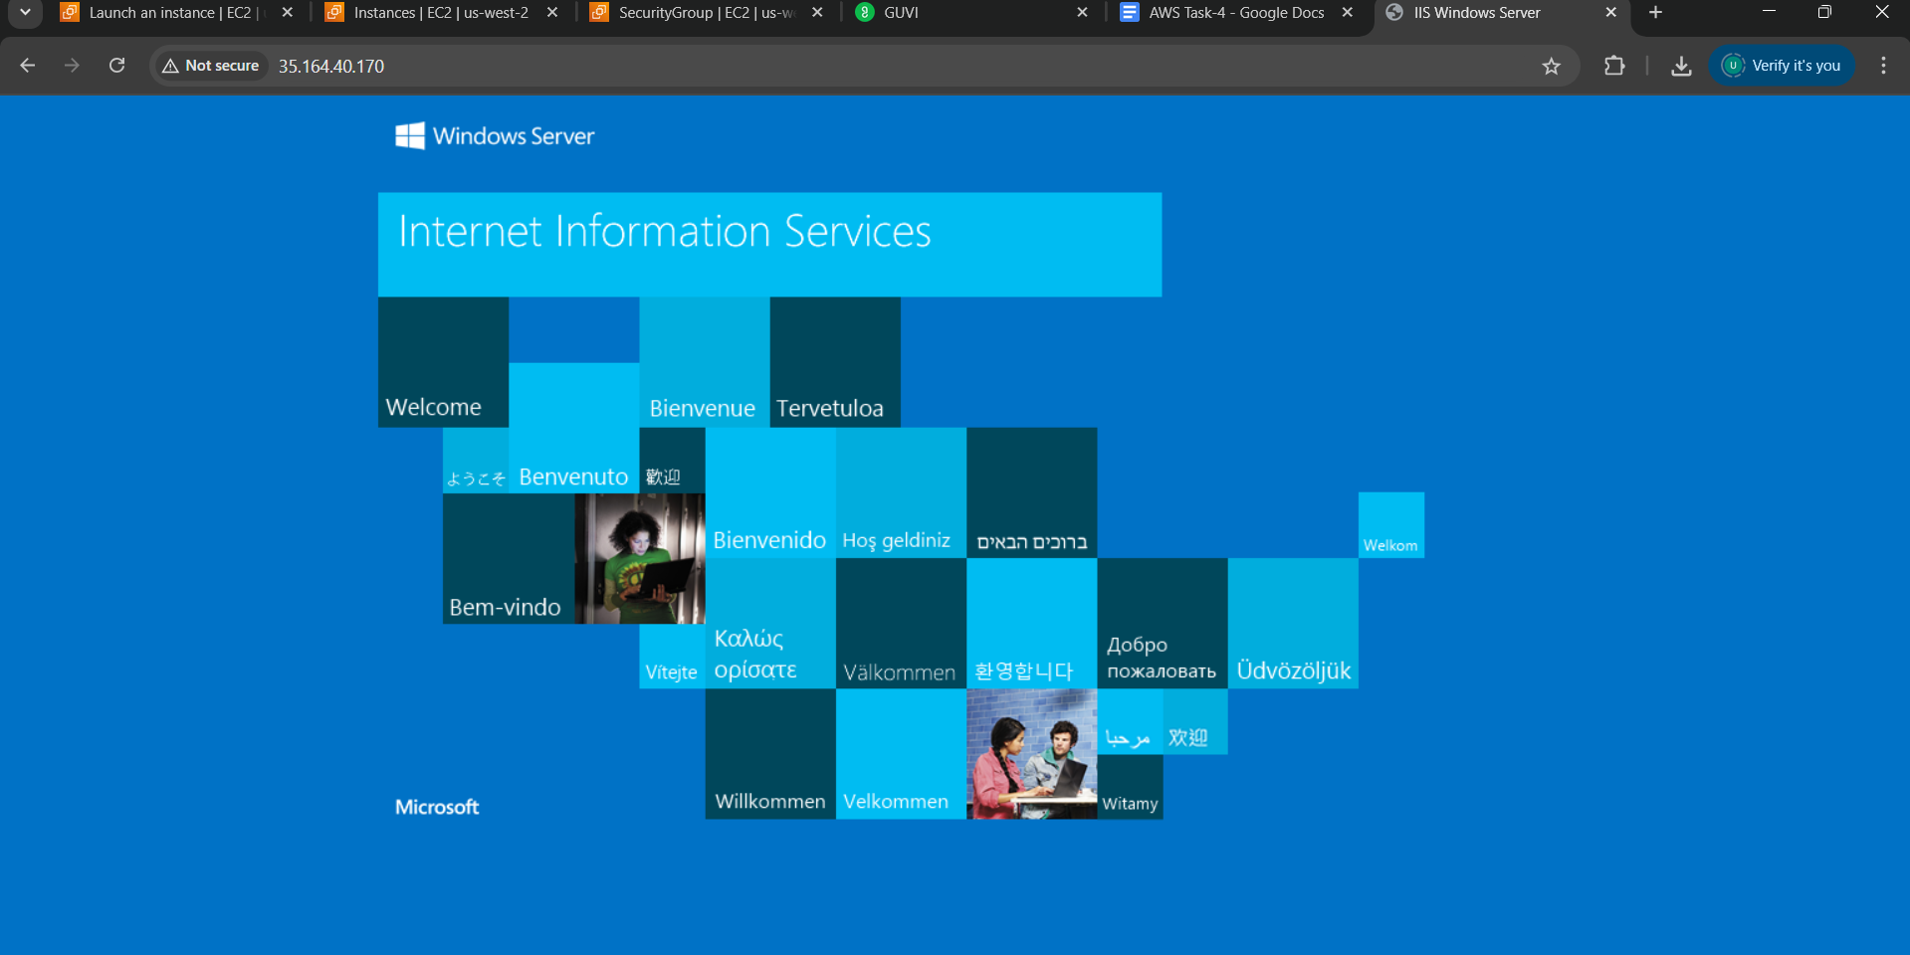

Step 3: Created and Attached a 5 GB EBS Volume

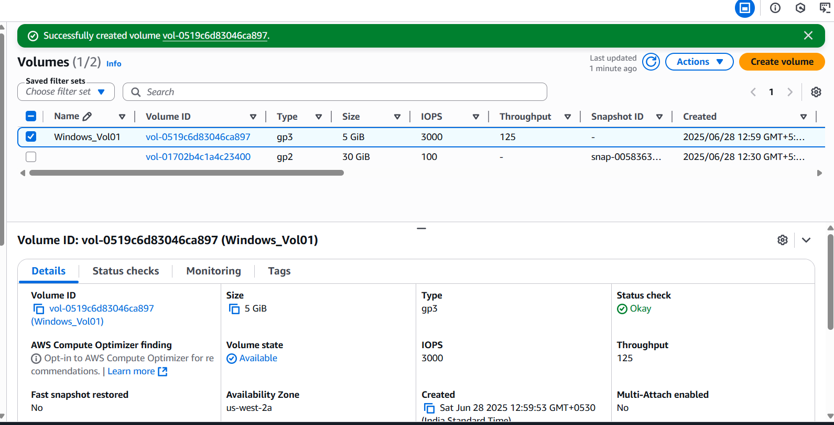

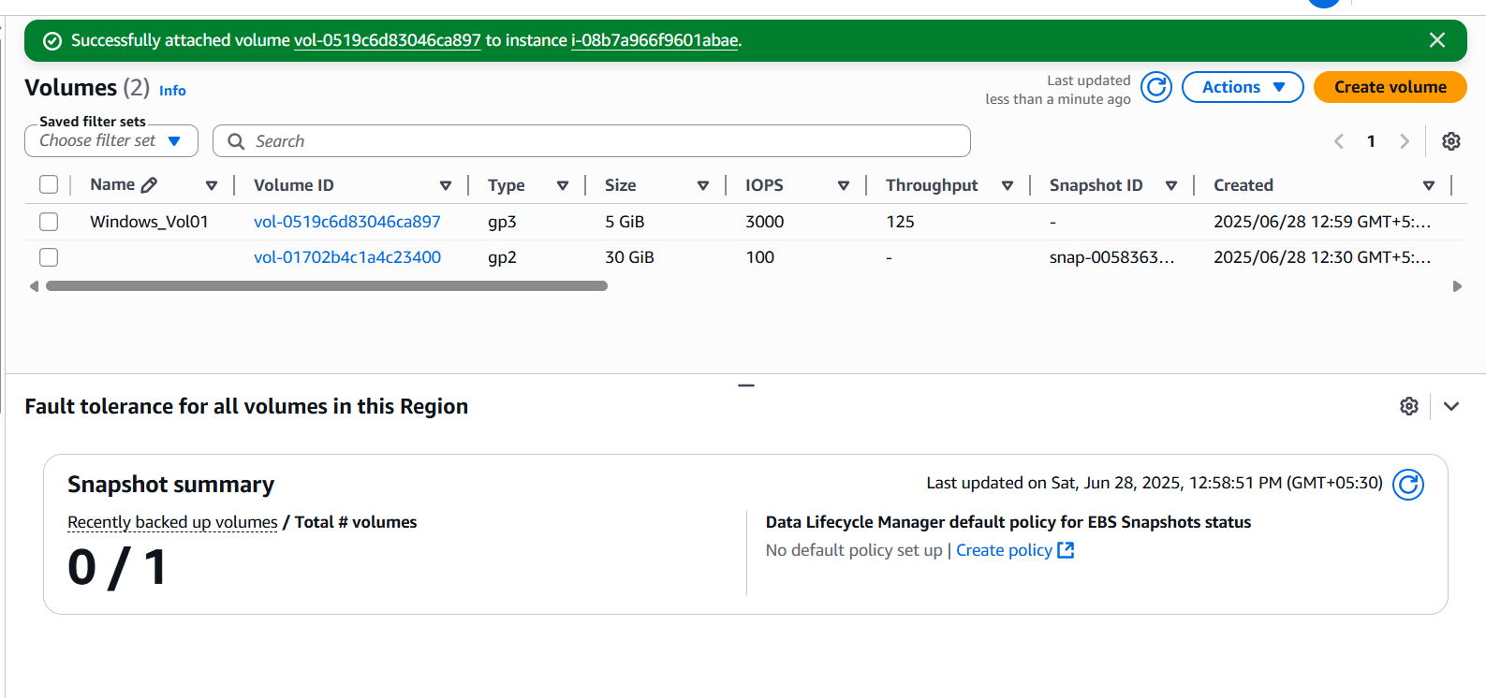

Step 4: Initialized and Formated Volume in Windows

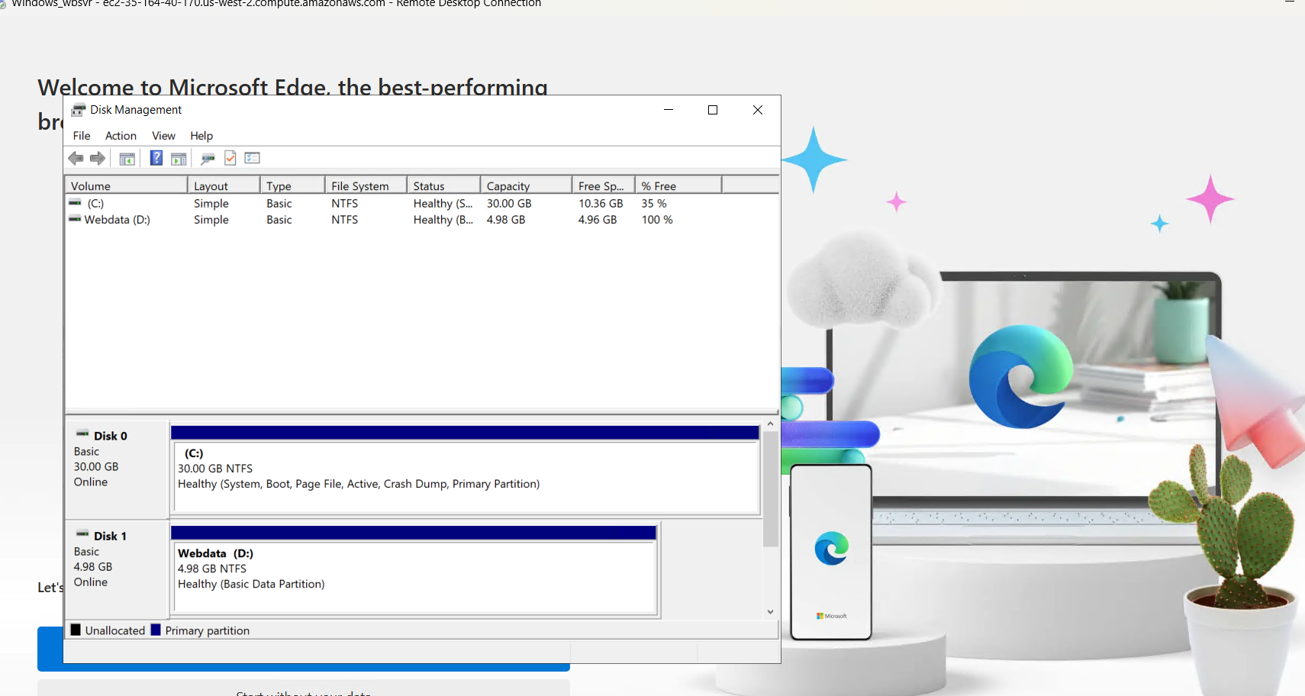

Step 5: Taken Snapshot of the Volume

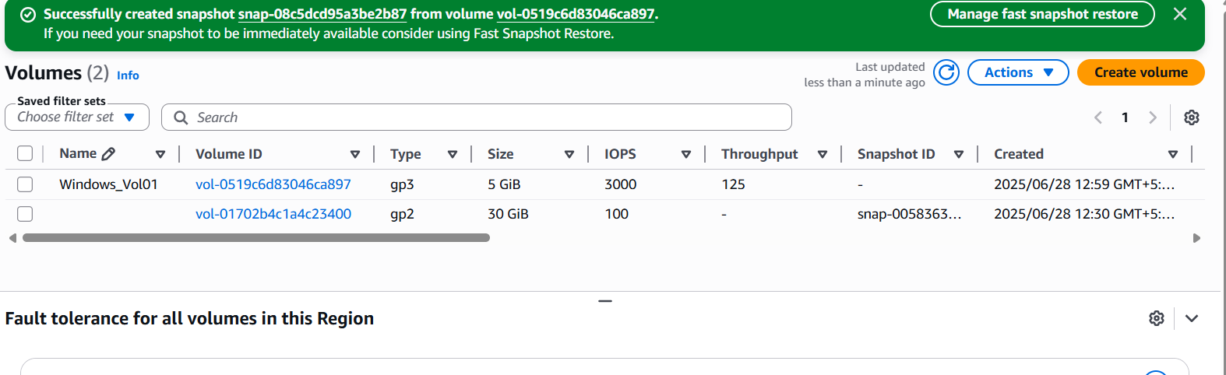

Step 6: Created a New EBS Volume from Snapshot

